Group 5 :
1. Danella Citra Aldarena / 5003231003
2. Aulia Rahmaeta Octaviani / 5003231009
3. Widyana Nityasa Manda / 5003231019
4. Najwa Allena Eka P. S. / 5003231025
5. Najwa Putri Lathifah / 5003231026

Forecasting International Tourist Arrivals to Bali via Ngurah Rai Airport
Dataset Source:
https://www.bps.go.id/id/statistics-table/2/MTE1MCMy/jumlah-kunjungan-wisatawan-mancanegara-per-bulan-ke-indonesia-menurut-pintu-masuk-2008-sekarang.html
From this dataset, only the Ngurah Rai Airport (Bali) entry point was selected because this airport serves as the primary gateway for international tourists entering Indonesia and consistently records the highest passenger volume each year. A final dataset focusing specifically on the Bali air entry point has been prepared:
https://docs.google.com/spreadsheets/d/1tMIaSDJBd1lmByDzFS2aPYHFoccUUUvi15e19QnQJ_c/edit?usp=sharing
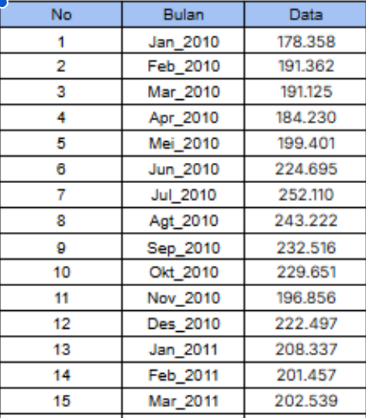
Dataset Description:
This dataset contains time-series data on the number of international tourist arrivals to Indonesia through the Ngurah Rai International Airport in Bali, covering the period from January 2010 to December 2024. The data are recorded on a monthly basis, forming a series of observations that reflect the dynamics of international tourism development in Bali over more than a decade. At the beginning of 2010, monthly arrivals ranged between 170,000 and 200,000 tourists, then showed a consistent upward trend, reaching more than 600,000 tourists per month in 2018–2019. A clear seasonal pattern is present, where arrivals tend to rise in the middle of the year—particularly from June to August—which corresponds to the summer holiday period in many tourist-origin countries.
Entering 2020, the dataset shows a drastic shift due to the COVID-19 pandemic. The number of arrivals sharply declined from more than 500,000 at the beginning of 2020 to only hundreds, tens, or even zero in several months during 2020–2021. This period represents a major anomaly in the time series, indicating the direct impact of international travel restrictions and border closures in many countries. Beginning in early 2022, the data illustrate a gradual recovery, marked by an increase from only a few thousand to hundreds of thousands of visitors within roughly two years. By 2023 and 2024, the seasonal pattern reappears, and the volume of arrivals approaches pre-pandemic levels, peaking at around 600,000 tourists in mid-2024.

